**DAILY ONLINE ACTIVITIES SUMMARY**

|  |  |  |  |  |  |  |  |  |  |
| --- | --- | --- | --- | --- | --- | --- | --- | --- | --- |
| **Date:** |  | **04-06-2020** | | |  |  | **Name:** | **Suhas Prasad Shetty** | |
|  |  |  |  |  |  |  |  |  |  |
| **Sem & Sec** |  | **8th sem B sec** | | |  |  | **USN:** | **4AL16CS080** | |
|  |  |  |  |  |  |  |  |  |  |
|  |  |  |  |  | **Online Test** | | **Summary** |  |  |
|  | |  |  |  |  |  |  |  |  |
| **Subject** | |  | **SMS** | |  |  |  |  |  |
|  | |  |  |  |  |  | |  |  |
| **Max. Marks** | |  | **60** |  |  | **Score** | | **60** |  |
|  |  |  |  |  | |  | |  |  |
|  |  |  |  | **Certification Course Summary** | | | | | |
|  | |  | |  | |  | |  |  |
| **Course** |  | **Getting started with aws security,identity and compliance** | | | | | |  |  |
|  |  | | |  |  |  | |  |  |
| **Certificate Provider** | | | | **AWS** |  | **Duration** | |  | **3 hours** |
|  |  |  |  |  |  |  | |  |  |
|  |  |  |  |  | **Coding Challenges** | | |  |  |
|  | | | | |  |  |  |  |  |
| **Problem Statement-** : | | | | |  |  |  |  |  |
|  |  |  |  | **Program to find HCF of two numbers** | | | | | |
|  | | | | |  |  |  |  |  |
| **Status: completed** | | | | |  |  |  |  |  |
|  | | | | |  |  | |  |  |
| **Uploaded the report in Github** | | | | |  | **yes** | |  |  |
|  | | | | |  |  | |  |  |
| **If yes Repository name** | | | | |  | **Suhas** | |  |  |
|  | | | | |  |  | |  |  |
| **Uploaded the report in slack** | | | | |  | **yes** | |  |  |
|  |  |  |  |  |  |  |  |  |  |

**Online Test Details**

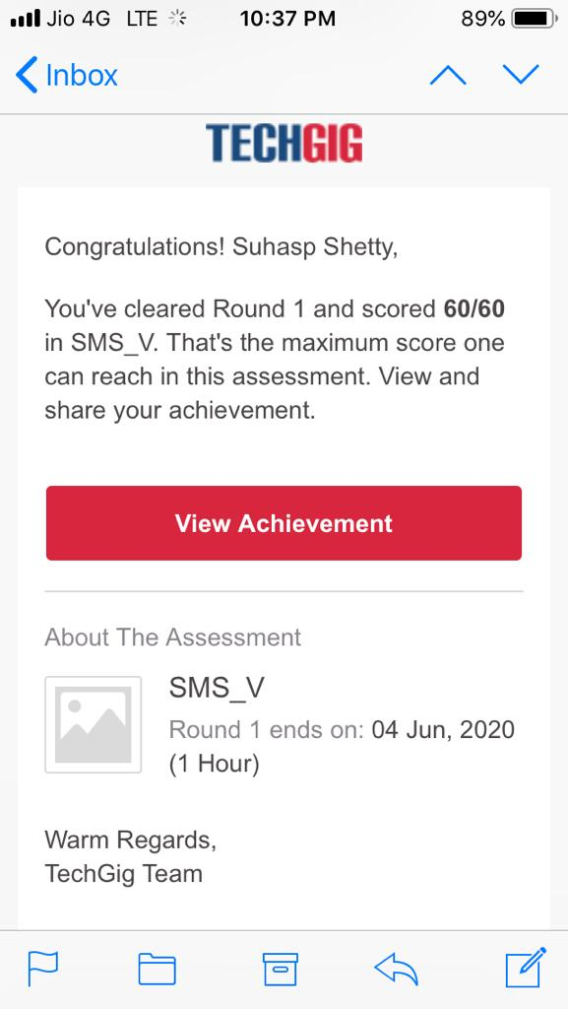

**Certification Course Details:**

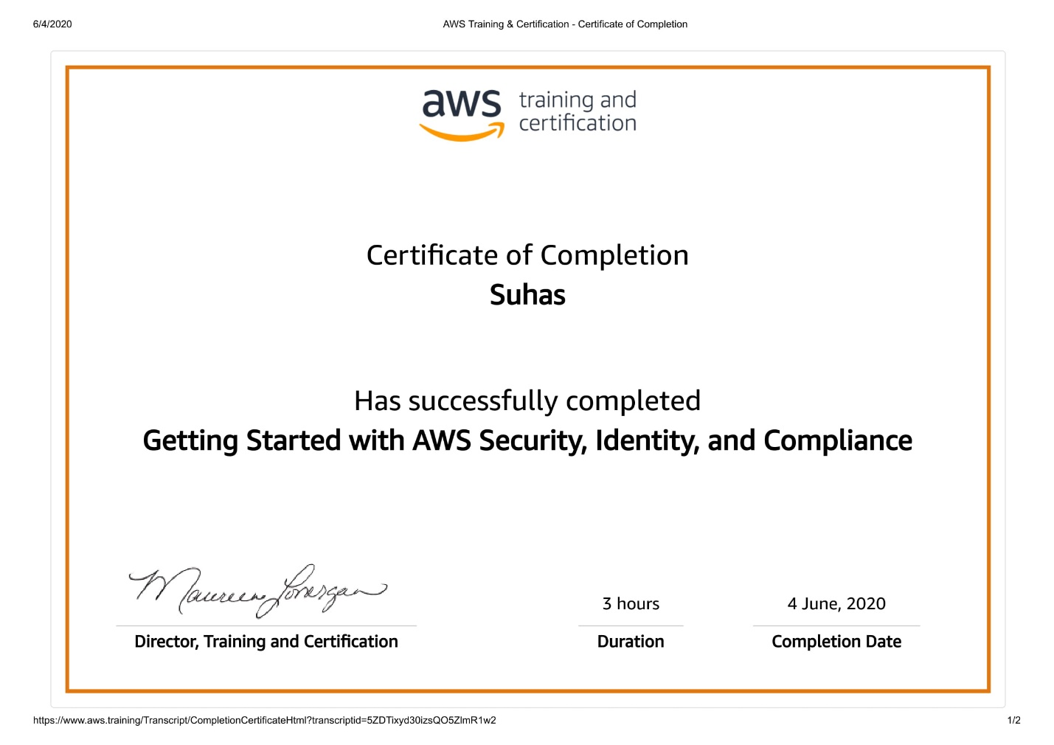

**.**

**Coding Challenges Details:**

**Python program to find H.C.F of two numbers**

**defcompute_hcf(x,y):**

**ifx>y:**

**smaller=y else:**

**smaller=x foriinrange(1,smaller+1):**

**if((x%i==0)and(y%i==0)):**

**hcf=i return hcf**

**num1=54**

**num2=24**

**print("TheH.C.F.is",compute_hcf(num1,num2))**